

Name: Muhammad Faisal
Roll no: 2022F-BCS-152

Section: C
Instructor Name: Miss Sabeen
Course: Data Structure & Algorithm Lab
Program: (BS) - Computer Science

Lab # 1
Task 1: Write a Program to enter three integers and output the smallest integers using IF.

Code:
#include <iostream>
using namespace std;

int main()
{
int arr[3];
int size = sizeof(arr) / sizeof(int);

cout << "Enter 3 integers: \n";
for (int i = 0; i < size; i++)
{
cin >> arr[i];
}

int small = arr[0];

if (small > arr[1]) {
small = arr[1];
}
if (small > arr[2]) {
small = arr[2];
}

cout << "The smallest integer is: " << small << endl;

return 0;
}

Output:
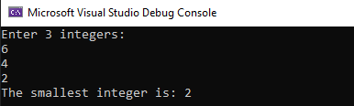

Task 2: Write a Program to enter 10 integers in a single-dimension array and then print out the array in ascending order.

Code:
#include <iostream>
using namespace std;

int main() {
int arr[10];
int size = sizeof(arr) / sizeof(int);

cout << "Enter 10 integers:\n";
for (int i = 0; i < size; i++) {
cin >> arr[i];
}

cout << "Array in ascending order: ";
for (int i = 0; i < size; i++) {
int minIndex = 0;
int minValue = INT_MAX;

for (int j = 0; j < size; j++) {
if (arr[j] < minValue) {
minValue = arr[j];
minIndex = j;
}
}

cout << minValue << " ";

arr[minIndex] = INT_MAX;
}

cout << endl;

return 0;
}

Output:
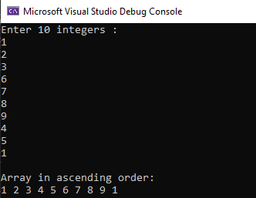

Task 3: Write a program to create structure named student. Take information of student from user as input (StdID, StdName, StdAge etc.) Display the output.

Code:
#include <iostream>
#include<string>
using namespace std;

struct student
{
string StdID;
string StdName;
int StdAge;
};

int main()
{
student arr[3];

cout << "Enter students detail: "<<endl;
for (int i = 0;i < 3;i++) {
cout << "Enter student " << i + 1 << " Id: ";
cin.ignore();
getline(cin, arr[i].StdID);

cout << "Enter student " << i + 1 << " name: ";
getline(cin, arr[i].StdName);

cout << "Enter student " << i + 1 << " age: ";
cin >> arr[i].StdAge;

cout << endl;
}

cout << "Students detail: " << endl;
for (int i = 0;i < 3;i++) {

cout << "Student " << i + 1 << " Id: " << arr[i].StdID << endl;
cout << "Student " << i + 1 << " name: " << arr[i].StdName << endl;
cout << "Student " << i + 1 << " age: " << arr[i].StdAge << endl;
cout << endl;
}
return 0;
}
Output:
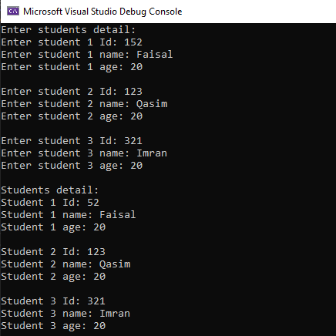

Task 4: Perform above task using pointers to structure

Code:
#include <iostream>
#include<string>
using namespace std;

struct student
{
string StdID;
string StdName;
int StdAge;
};
int main()
{
student arr[3];

cout << "Enter students detail: "<<endl;
for (int i = 0;i < 3;i++) {
student* ptr = &arr[i];
cout << "Enter student " << i + 1 << " Id: ";
cin.ignore();
getline(cin, ptr->StdID);

cout << "Enter student " << i + 1 << " name: ";
getline(cin, ptr->StdName);

cout << "Enter student " << i + 1 << " age: ";
cin >> ptr->StdAge;

cout << endl;
}

cout << "Students detail: " << endl;
for (int i = 0;i < 3;i++) {

cout << "Student " << i + 1 << " Id: " << arr[i].StdID << endl;
cout << "Student " << i + 1 << " name: " << arr[i].StdName << endl;
cout << "Student " << i + 1 << " age: " << arr[i].StdAge << endl;
cout << endl;
}
return 0;
}

Output:
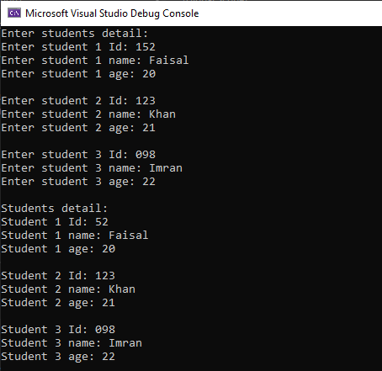

Lab # 2
Task 1: Create a program that take an array of 10 inputs from the user and generate the sorted out put using the following Algorithms;

  - Bubble Sort

  - Insertion Sort

  - Selection Sort

Bubble Sort

Code:
#include <iostream>
using namespace std;

int main()
{
int arr[10];
int size = sizeof(arr) / sizeof(int);
int swap, temp;

cout << "Enter 10 integers : \n";
for (int i = 0; i < size; i++)
{
cin >> arr[i];
}
for (int i = 0;i < size - 1;i++) {
swap = 0;
for (int j = 0;j < (size - i) - 1;j++) {
if (arr[j] > arr[j + 1]) {
temp = arr[j];
arr[j] = arr[j + 1];
arr[j + 1] = temp;
swap = 1;
}
}
if (swap == 0) {
break;
}
}
cout << "\nSorted output using Bubble Sort \n";
for (int i = 0; i < size; i++)
{
cout << arr[i] << " ";

}
return 0;
}

Output:
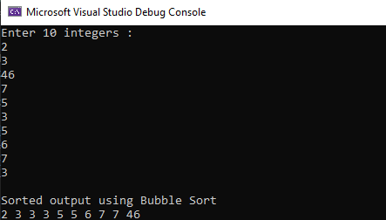

Insertion Sort

Code:
#include <iostream>
using namespace std;

int main()
{
int arr[10];
int size = sizeof(arr) / sizeof(int);
int temp,j=0;

cout << "Enter 10 integers : \n";
for (int i = 0; i < size; i++)
{
cin >> arr[i];
}
for (int i = 1;i < size ;i++) {
temp = arr[i];
j = i - 1;
while (j>=0 && arr[j]>temp)
{
arr[j + 1] = arr[j];
j--;
}
arr[j + 1] = temp;
}
cout << "\nSorted output using Insertion Sort\n";
for (int i = 0; i < size; i++)
{
cout << arr[i] << " ";

}
return 0;
}

Output:
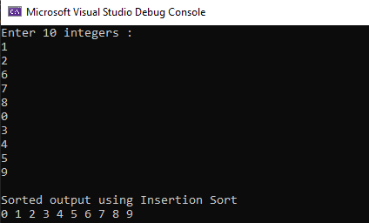

Selection Sort

Code:
#include <iostream>
using namespace std;

int main()
{
int arr[10];
int size = sizeof(arr) / sizeof(int);
int min,loc,temp;

cout << "Enter 10 integers : \n";
for (int i = 0; i < size; i++)
{
cin >> arr[i];
}
for (int i = 0;i < size-1 ;i++) {
min = arr[i];
loc=i;
for (int j = i + 1; j < size;j++) {
if (arr[j] < min) {
min = arr[j];
loc = j;
}
}

temp = arr[i];
arr[i] = arr[loc];
arr[loc] = temp;
}
cout << "\nSorted output using Selection Sort\n";
for (int i = 0; i < size; i++)
{
cout << arr[i] << " ";

}
return 0;
}

Output:

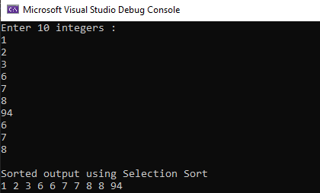

Lab # 3
Task 1: Translate the linear search algorithm in to a program which either find the location LOC where ITEM appears in ARRAY or return LOC=0

Code:
#include <iostream>
using namespace std;

int linearSearch(int arr[], int item, int size) {
for (int i = 0; i < size; i++) {
if (arr[i] == item) {
return i + 1;
}
}
return 0;
}
int main() {
int arr[] = { 3, 1, 4, 1, 5, 9, 2, 6, 5, 3, 5 };
int size = sizeof(arr) / sizeof(int);
int x, r;

cout << "Enter the number to search: ";
cin >> x;

r= linearSearch(arr, x, size);

if (r != 0) {
cout << x << " found at location " << r <<endl;
}
else {
cout << x << " not found in the array" <<endl;
}
return 0;
}
Output:
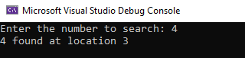

Task 2: Translate binary search and insertion algorithm in to a program which finds either the location LOC where ITEM appears in ARRAY or the location LOC where ITEM should be inserted into ARRAY. (For object 3, 4, and 5 take an array of 10 elements given below)

Code:
#include <iostream>
#include <algorithm>
#include <vector>
using namespace std;

int BinarySearchInsertion(int arr[], int target, int size) {
int left = 0;
int right = size - 1;

while (left <= right) {
int mid = (right + left) / 2;

if (arr[mid] == target) {
return mid; // Item found, return its location
}
else if (arr[mid] < target) {
left = mid + 1;
}
else {
right = mid - 1;
}
}
return left; // Item not found, return the location for insertion
}

int main() {
int x;
int arr[10];
int size = sizeof(arr) / sizeof(int);

cout << "Enter 10 integers: " << endl;
for (int i = 0; i < size; i++) {
cin >> arr[i];
}

sort(arr, arr + size);

cout << "Enter the number to search or insert: ";
cin >> x;

int result = BinarySearchInsertion(arr, x, size);

if (arr[result] == x) {
cout << x << " found at index: " << result << endl;
}
else {
cout << x << " should be inserted at index: " << result << endl;
}

return 0;
}
Output:
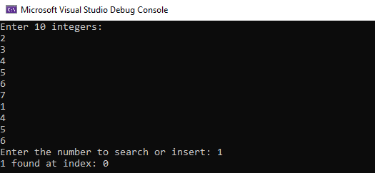

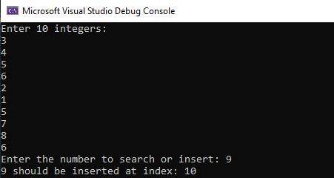

Task 3: Write a program which uses Binary Search to search the elements52, and 33 and print it.

Code:
#include <iostream>
#include <algorithm>
using namespace std;

int BinarySearch(int arr[], int size, int target) {
int left = 0;
int right = size - 1;

while (left <= right) {
int mid = left + (right - left) / 2;

if (arr[mid] == target) {
return mid; // Item found, return its location
}
else if (arr[mid] < target) {
left = mid + 1;
}
else {
right = mid - 1;
}
}
return -1; // Item not found
}

int main() {
int arr[] = { 12, 22, 33, 44, 52, 62, 72, 82, 92 };
int size = sizeof(arr) / sizeof(arr[0]);

int target1 = 52;
int target2 = 33;

int result1 = BinarySearch(arr, size, target1);
int result2 = BinarySearch(arr, size, target2);

if (result1 != -1) {
cout << target1 << " found at index: " << result1 << endl;
}
else {
cout << target1 << " not found in the array" << endl;
}

if (result2 != -1) {
cout << target2 << " found at index: " << result2 << endl;
}
else {
cout << target2 << " not found in the array" << endl;
}

return 0;
}

Output:
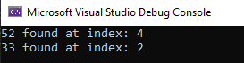

Task 4: Write a program which uses Binary Search to search the elements 45 and 78 and delete it. NUMBERS=[11,22,33,36,45,52,57,60,64,78]
Code:
#include <iostream>
using namespace std;

int binarySearchAndDelete(int arr[], int target, int& size) {
int left = 0;
int right = size - 1;

while (left <= right) {
int mid = left + (right - left) / 2;

if (arr[mid] == target) {
// Element found, delete it
for (int i = mid; i < size - 1; ++i) {
arr[i] = arr[i + 1];
}
size--; // Decrease the size of the array
return mid;
}
else if (arr[mid] < target) {
left = mid + 1;
}
else {
right = mid - 1;
}
}
return -1; // Element not found
}

int main() {
int target1 = 45;
int target2 = 78;
int arr[10] = { 11, 22, 33, 36, 45, 52, 57, 60, 64, 78 };
int size = sizeof(arr) / sizeof(int);

int result1 = binarySearchAndDelete(arr, target1, size);
int result2 = binarySearchAndDelete(arr, target2, size);

if (result1 == -1) {
cout << target1 << " was not found in the array" << endl;
}
else {
cout << target1 << " found at index " << result1 << " and deleted." << endl;
}

if (result2 == -1) {
cout << target2 << " was not found in the array" << endl;
}
else {
cout << target2 << " found at index " << result2 << " and deleted." << endl;
}

cout << "Updated array after deletion: ";
for (int i = 0; i < size; ++i) {
cout << arr[i] << " ";
}

return 0;
}
Output:
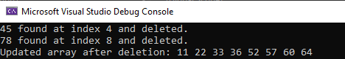

Lab # 4
Task 1: Write a program as follows

Linked List implementation of LIST ADT

- Insert an element at the end

- Delete an element from end

- Search an element

- Display List

- Is List Empty

Exit
Code:
#include <iostream>
using namespace std;

struct Node {
int data;
Node* next;
Node(int value) : data(value), next(nullptr) {}
};

void insertAtEnd(Node*& head, int value) {
Node* newNode = new Node(value);

if (head == nullptr) {
head = newNode;
return;
}

Node* current = head;
while (current->next != nullptr) {
current = current->next;
}

current->next = newNode;
}

void deleteFromEnd(Node*& head) {
if (head == nullptr) {
cout << "List is empty. Cannot delete.\n";
return;
}

if (head->next == nullptr) {
delete head;
head = nullptr;
return;
}

Node* current = head;
Node* previous = nullptr;

while (current->next != nullptr) {
previous = current;
current = current->next;
}

delete current;
previous->next = nullptr;
}

int searchElement(Node* head, int value) {
Node* current = head;
int position = 1;

while (current != nullptr) {
if (current->data == value) {
return position;
}

current = current->next;
position++;
}

return -1;
}

void displayList(Node* head) {
cout << "List: ";
Node* current = head;

while (current != nullptr) {
cout << current->data << " -> ";
current = current->next;
}

cout << "NULL\n";
}

bool isListEmpty(Node* head) {
return head == nullptr;
}

int main() {
Node* head = nullptr;
int choice, element, position;

do {
cout << "\n1. Insert at End\n";
cout << "2. Delete from End\n";
cout << "3. Search an Element\n";
cout << "4. Display List\n";
cout << "5. Is List Empty\n";
cout << "6. Exit\n";
cout << "Enter your choice: ";
cin >> choice;

switch (choice) {
case 1:
cout << "Enter the element to insert: ";
cin >> element;
insertAtEnd(head, element);
break;

case 2:
deleteFromEnd(head);
break;

case 3:
cout << "Enter the element to search: ";
cin >> element;
position = searchElement(head, element);
if (position != -1) {
cout << "Element found at position " << position << "\n";
}
else {
cout << "Element not found in the list\n";
}
break;

case 4:
displayList(head);
break;

case 5:
if (isListEmpty(head)) {
cout << "The list is empty.\n";
}
else {
cout << "The list is not empty.\n";
}
break;

case 6:
cout << "Exiting the program.\n";
break;

default:
cout << "Invalid choice. Please enter a valid option.\n";
}
} while (choice != 6);

while (head != nullptr) {
Node* temp = head;
head = head->next;
delete temp;
}

return 0;
}
Output:
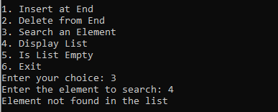
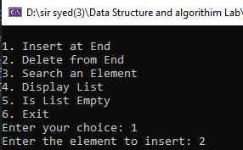

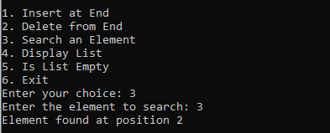
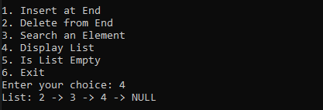

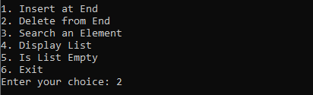

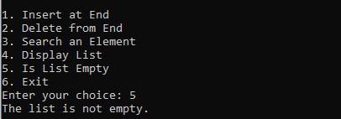

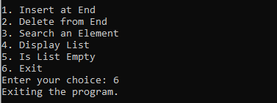

Lab # 5
Task 1: Write a program as follows for STACK
--------------------------------------Array based implementation of STACK-----------------------------------------------
1. Push an element on stack
2. Pop an element from stack
3. Display all
4. Top element
5. Exit
-----------------------------------------------------------------------------------------------------------------------------------
Please Enter Your Choice:

Code:
#include <iostream>
using namespace std;

const int N= 10;
int stack[N];
int top = -1;
int total = 0;

void push(int x)
{

if (top == N-1) {
cout << "stack overflow";
return;
}
else {

top++;
stack[top] = x;
}

}
void pop() {
if (top == -1) {
cout << "No element to pop";
}
else {
top--;
}
}
void Display() {
int i;
cout << "Stack: ";
for (int i = 0; i <= top; i++) {
cout << " " << stack[i];
}
cout << endl;
}

void top_element() {
if (top == -1) {
cout << "Stack is empty. No top element" << endl;
}
else {
cout << "Top element is: " <<stack[top]<< endl;
}
}
int main()
{
int choice, x;
cout << "-----------------------Array based implementation of STACK---------------------------" << endl;

do {
cout << "\n1. Push an element on stack\n";
cout << "2. Pop an element from stack\n";
cout << "3. Display all\n";
cout << "4. Top element\n";
cout << "5. Exit\n";
cout << "-------------------------------------------------------------------------------------" << endl;
cout << "\nPlease Enter Your Choice: ";
cin >> choice;

switch (choice) {
case 1:
cout << "\nEnter an element to push on stack: ";
cin >> x;
push(x);
break;
case 2:
pop();
break;

case 3:
Display();
break;

case 4:
top_element();
break;

case 5:
cout << "Exiting the program.\n";
break;

default:
cout << "Invalid choice. Please enter a valid option.\n";
}
} while (choice != 5);

return 0;
}

Output:
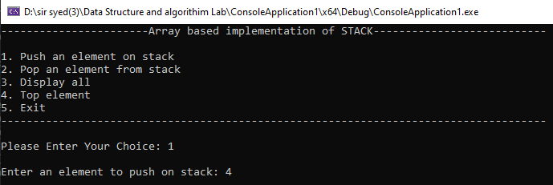

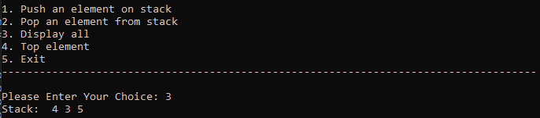

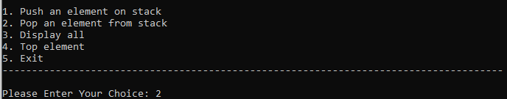

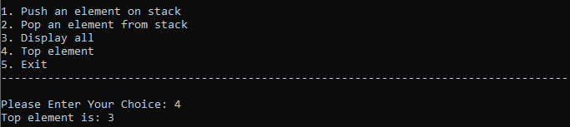

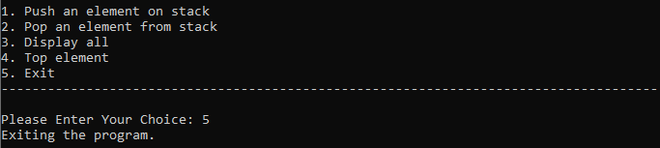

Task 2: Test the program using the following procedure: STACK of size N=6
1. Call PUSH(5)
2. Call PUSH(2)
3. Call PUSH(3)
4. Call POP()
5. Call PUSH(6)
6. Call PUSH(9)
7. Call PUSH(3)
8. Call DISPLAY()
9. Call TOP()

Code:
#include <iostream>
using namespace std;

const int N= 6;
int stack[N];
int top = -1;

void push(int x) {
if (top == N - 1) {
cout << "Stack overflow\n";
}
else {
top++;
stack[top] = x;
cout << x << " pushed onto the stack.\n";
}
}

void pop() {
if (top == -1) {
cout << "Stack is empty. Cannot pop.\n";
}
else {
cout << stack[top] << " popped from the stack.\n";
top--;
}
}

void display() {
if (top == -1) {
cout << "Stack is empty.\n";
}
else {
cout << "Stack: ";
for (int i = 0; i <= top; i++) {
cout << stack[i] << " ";
}
cout << endl;
}
}

void topElement() {
if (top == -1) {
cout << "Stack is empty. No top element.\n";
}
else {
cout << "Top element is: " << stack[top] << endl;
}
}

int main() {
cout << "Testing Array-based implementation of STACK\n";

push(5);
push(2);
push(3);
pop();
push(6);
push(9);
push(3);
display();
topElement();

return 0;
}

Output:
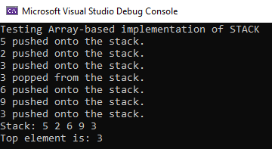

Lab # 6
Task 1: Write a program as follows for QUEUE
--------------------------------------Array based implementation of QUEUE -----------------------------------------------

1. Enqueue an element to queue
2. Dequeue an element from queue
3. Display all
4. Exit
-----------------------------------------------------------------------------------------------------------------------------------
Please Enter Your Choice:

Code:
#include <iostream>
using namespace std;

const int N= 10;
int queue[N];
int front = -1;
int rear = -1;

void enqueue(int x) {
if (rear == N-1) {
cout << "Queue is full. Cannot enqueue.\n";
}
else {
if (front == -1) {
front = 0;
}
rear++;
queue[rear] = x;
cout << x << " enqueued to the queue.\n";
}
}

void dequeue() {
if (front == -1) {
cout << "Queue is empty. Cannot dequeue.\n";
}
else {
cout << queue[front] << " dequeued from the queue.\n";
front++;
if (front > rear) {
front = rear = -1;
}
}
}

void display() {
if (front == -1) {
cout << "Queue is empty.\n";
}
else {
cout << "Queue: ";
for (int i = front; i <= rear; i++) {
cout << queue[i] << " ";
}
cout << endl;
}
}

int main() {
int choice, x;

cout << "-----------------------Array based implementation of QUEUE---------------------------" << endl;

do {
cout << "\n1. Enqueue an element to queue\n";
cout << "2. Dequeue an element from queue\n";
cout << "3. Display all\n";
cout << "4. Exit\n";
cout << "-------------------------------------------------------------------------------------" << endl;
cout << "\nPlease Enter Your Choice: ";
cin >> choice;

switch (choice) {
case 1:
cout << "Enter an element to enqueue: ";
cin >> x;
enqueue(x);
break;

case 2:
dequeue();
break;

case 3:
display();
break;

case 4:
cout << "Exiting the program.\n";
break;

default:
cout << "Invalid choice. Please enter a valid option.\n";
}
} while (choice != 4);

return 0;
}

Output:
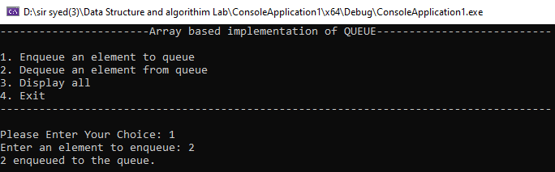

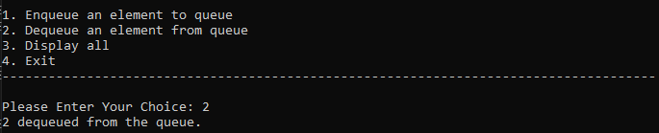

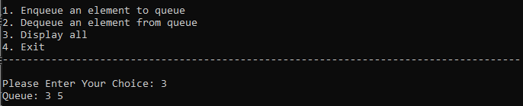

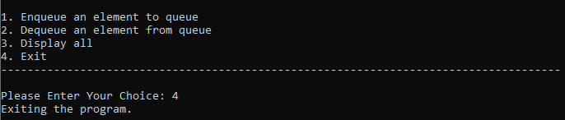

Task 2: Test the program using the following procedure: QUEUE of size N=6
Call enQueue(5)
Call enQueue(2)
Call enQueue(3)
Call deQueue()
Call deQueue()
Call enQueue(6)
Call enQueue(3)
Call Display()

Code:
#include <iostream>
using namespace std;

const int N= 6;
int queue[N];
int front = -1;
int rear = -1;

void enQueue(int x) {
if (rear == N-1) {
cout << "Queue is full. Cannot enQueue.\n";
}
else {
if (front == -1) {
front = 0;
}
rear++;
queue[rear] = x;
cout << x << " enqueued to the queue.\n";
}
}

void deQueue() {
if (front == -1) {
cout << "Queue is empty. Cannot deQueue.\n";
}
else {
cout << queue[front] << " dequeued from the queue.\n";
front++;
if (front > rear) {
front = rear = -1;
}
}
}

void display() {
if (front == -1) {
cout << "Queue is empty.\n";
}
else {
cout << "Queue: ";
for (int i = front; i <= rear; i++) {
cout << queue[i] << " ";
}
cout << endl;
}
}

int main() {
cout << "Testing Array-based implementation of QUEUE\n";

enQueue(5);
enQueue(2);
enQueue(3);
deQueue();
deQueue();
enQueue(6);
enQueue(3);
display();

return 0;
}

Output:

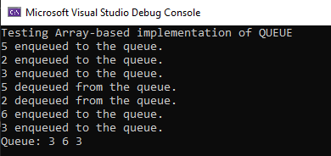

Lab # 7
Task 1: Write a program to create a Tree for the following.
Insert Sequence of data: 52, 25, 60, 35, 20, 59, 65

Code:
#include <iostream>
using namespace std;

struct TreeNode {
int data;
TreeNode* left;
TreeNode* right;

TreeNode(int value) {
data = value;
left = nullptr;
right = nullptr;
}
};

TreeNode* insert(TreeNode* node, int value) {
if (node == nullptr) {
return new TreeNode(value);
}

if (value < node->data) {
node->left = insert(node->left, value);
}
else if (value > node->data) {
node->right = insert(node->right, value);
}

return node;
}

void inOrderTraversal(TreeNode* node) {
if (node != nullptr) {
inOrderTraversal(node->left);
cout << node->data << " ";
inOrderTraversal(node->right);
}
}

int main() {
TreeNode* root = nullptr;

root = insert(root, 52);
insert(root, 25);
insert(root, 60);
insert(root, 35);
insert(root, 20);
insert(root, 59);
insert(root, 65);

cout << "In-order traversal of the tree: ";
inOrderTraversal(root);
cout << std::endl;

return 0;
}

Output:

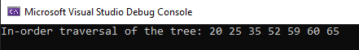

Lab # 8
Task 1: Write a program to to print the nodes of the following Tree diagram through Pre-Order, InOrder. and Post-Order.
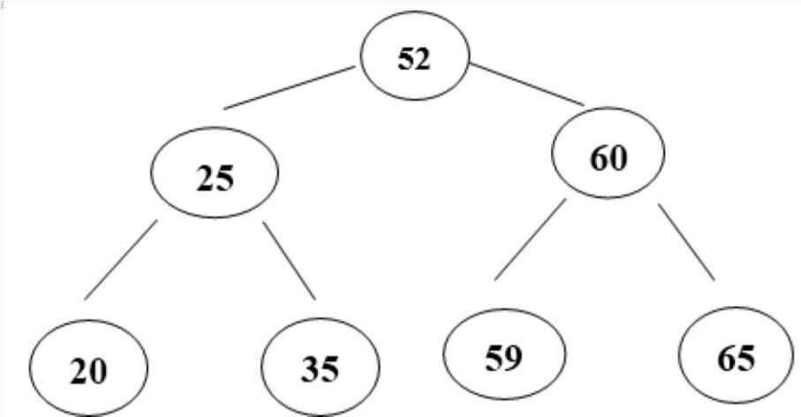

Code:
#include<iostream>
using namespace std;

struct TreeNode {
int data;
TreeNode* left;
TreeNode* right;

TreeNode(int value) : data(value), left(nullptr), right(nullptr) {}
};

// PreOrder traversal - visit the parent first and then left and right children;
void preOrderTraversal(TreeNode* root) {
if (root == nullptr) {
return;
}
cout << root->data << ", ";
preOrderTraversal(root->left);
preOrderTraversal(root->right);
}

// InOrder traversal - visit the left child, then the parent and the right child;
void inOrderTraversal(TreeNode* root) {
if (root == nullptr) {
return;
}
inOrderTraversal(root->left);
cout << root->data << ", ";
inOrderTraversal(root->right);
}

// PostOrder traversal - visit left child, then the right child and then the parent;
void postOrderTraversal(TreeNode* root) {
if (root == nullptr) {
return;
}
postOrderTraversal(root->left);
postOrderTraversal(root->right);
cout << root->data << ", ";
}

TreeNode* insert(TreeNode* root, int data) {
if (root == nullptr) {
return new TreeNode(data);
}

if (data < root->data) {
root->left = insert(root->left, data);
}
else if (data > root->data) {
root->right = insert(root->right, data);
}

return root;
}

int main() {
TreeNode* root = nullptr;

root = insert(root, 52);
root = insert(root, 25);
root = insert(root, 60);
root = insert(root, 20);
root = insert(root, 35);
root = insert(root, 59);
root = insert(root, 65);

cout << "We have Inserted: 52, 25, 60, 20, 35, 59, 65" << endl;

cout << "\nPreorder: ";
preOrderTraversal(root);

cout << "\nInorder: ";
inOrderTraversal(root);

cout << "\nPostorder: ";
postOrderTraversal(root);
cout << std::endl;

return 0;
}

Output:
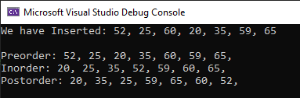

Lab # 9

Implementation of Graph and its representation

Task 1: Implement representation of graph by Adjacency Matrix and Adjacency List.

Code:
#include <iostream>
#include <list>
using namespace std;

const int MAX_VERTICES = 50;

int AdjMatrix[MAX_VERTICES][MAX_VERTICES];

// This function will print Adjacency Matrix
void printAdjMatrix(int v) {
cout << "\n\tAdjacency Matrix for undirected Graph:\n" << endl;

for (int i = 0; i < v; i++) {
for (int j = 0; j < v; j++) {
cout << AdjMatrix[i][j] << " ";
}
cout << endl;
}
}

// This function will mark the vertices which have edges between them
void addEdgeMatrix(int x, int y) {
AdjMatrix[x][y] = AdjMatrix[y][x] = 1;
}

// This function will push element into a list from back
void addEdgeList(list<int>* l, int x, int y) {
l[x].push_back(y);
l[y].push_back(x);
}

// This function will print Adjacency List
void printAdjList(list<int>* l, int v) {
cout << "\n\tAdjacency List for undirected Graph:\n" << endl;

for (int i = 0; i < v; i++) {
cout << i;
for (auto nbr : l[i]) {
cout << "-->" << nbr;
}
cout << endl;
}
}

int main() {
int v, e, x, y;

cout << "\n\tEnter the number of vertices in Graph: ";
cin >> v;

cout << "\tEnter the number of edges in Graph: ";
cin >> e;
cout << "\n\t" << endl;

// 1D array for adjacency list
list<int>* graphList = new list<int>[v];

for (int i = 0; i < e; i++) {
cout << "\tEnter edge number " << (i + 1) << ": ";
cin >> x >> y;

addEdgeMatrix(x, y);

addEdgeList(graphList, x, y);
}

cout << endl;

printAdjMatrix(v);

cout << endl;

printAdjList(graphList, v);

delete[] graphList; // free memory allocated for adjacency list

return 0;
}

Output:

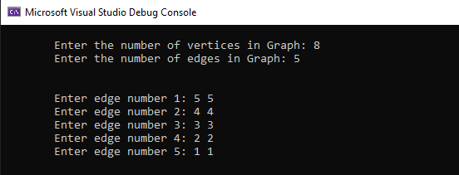

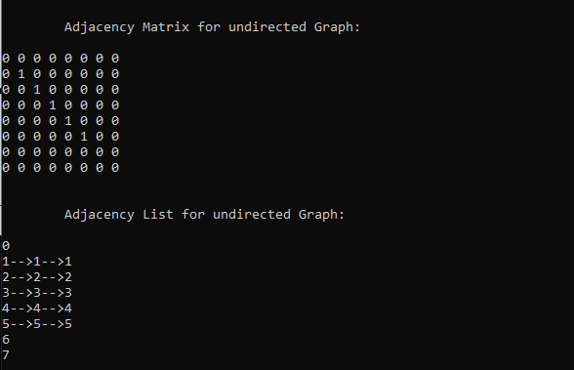

Lab # 10

Implementation of Breadth first and Depth first Traversal for a Graph

Task 1: Implement Breadth first and Depth first Traversal for a Graph.

Code:
#include <iostream>
#include <list>
#include <queue>

using namespace std;

class Graph {
int V;
list<int>* l;

public:
Graph(int V) {
this->V = V;
l = new list<int>[V];
}

void AddEdge(int x, int y) {
l[x].push_back(y);
}

void BreadthFirstTraversal(int S) {
bool* visited = new bool[V];
for (int i = 0; i < V; i++) {
visited[i] = false;
}

queue<int> q;
visited[S] = true;
q.push(S);

while (!q.empty()) {
S = q.front();
cout << S << " ";
q.pop();

for (auto i = l[S].begin(); i != l[S].end(); i++) {
if (!visited[*i]) {
visited[*i] = true;
q.push(*i);
}
}
}
}

void DFS_visit(int d, bool visited[]) {
visited[d] = true;
cout << d << " ";

for (auto i = l[d].begin(); i != l[d].end(); i++) {
if (!visited[*i]) {
DFS_visit(*i, visited);
}
}
}

void DepthFirstTraversal(int d) {
bool* visited = new bool[V];
for (int i = 0; i < V; i++) {
visited[i] = false;
}

DFS_visit(d, visited);
}
};

int main() {
int v, e, x, y, k;

cout << "Enter the number of vertices in Graph: ";
cin >> v;

cout << "Enter the number of edges in Graph: ";
cin >> e;

Graph g(v);

for (int i = 0; i < e; i++) {
cout << "Enter edge number " << (i + 1) << ": ";
cin >> x >> y;
g.AddEdge(x, y);
}

cout << "Enter source vertex: ";
cin >> k;

cout << "Breadth First Traversal of given Graph is: ";
g.BreadthFirstTraversal(k);
cout << endl;

cout << "Depth First Traversal of given Graph is: ";
g.DepthFirstTraversal(k);
cout << endl;

return 0;
}

Output:
